Avengers Arena Database Design Document

# Entity Relationship Diagram

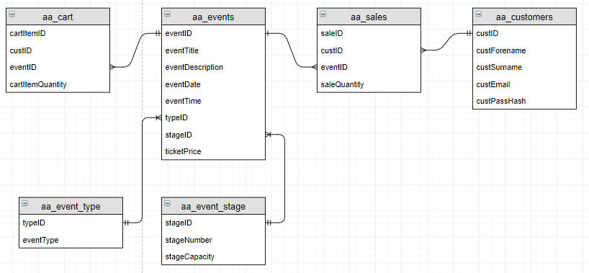

# Data Dictionary

## aa_events

|  |  |  |  |  |  |
| --- | --- | --- | --- | --- | --- |
| **Attribute name** | **Data type** | **Size** | **Constraint** | **Null?** | **Comment** |
| eventID | Number | 15 | Primary key |  |  |
| eventTitle | VARCHAR | 100 |  |  |  |
| eventDescription | VARCHAR | 500 |  |  |  |
| eventDate | VARCHAR |  |  |  |  |
| eventTime | VARCHAR |  |  |  |  |
| typeID | VARCHAR | 5 | Foreign key |  |  |
| stageID | VARCHAR | 5 | Foreign key |  |  |
| ticketPrice | Number | 8 |  |  |  |

## aa_event_type

|  |  |  |  |  |  |
| --- | --- | --- | --- | --- | --- |
| **Attribute name** | **Data type** | **Size** | **Constraint** | **Null?** | **Comment** |
| typeID | Number |  | Primary key |  |  |
| eventType | VARCHAR |  |  |  |  |

## aa_event_stage

|  |  |  |  |  |  |
| --- | --- | --- | --- | --- | --- |
| **Attribute name** | **Data type** | **Size** | **Constraint** | **Null?** | **Comment** |
| stageID | VARCHAR |  | Primary key |  |  |
| stageNumber | VARCHAR |  |  |  |  |
| stageCapacity | Number |  |  |  |  |

## aa_sales

|  |  |  |  |  |  |
| --- | --- | --- | --- | --- | --- |
| **Attribute name** | **Data type** | **Size** | **Constraint** | **Null?** | **Comment** |
| saleID | Number |  | Primary key |  |  |
| custID | Number |  | Foreign key |  |  |
| eventID | Number |  | Foreign key |  |  |
| saleQuantity | Number |  |  |  |  |

## aa_customer

|  |  |  |  |  |  |
| --- | --- | --- | --- | --- | --- |
| **Attribute name** | **Data type** | **Size** | **Constraint** | **Null?** | **Comment** |
| custID | Number | 10 | Primary key |  |  |
| custForename | VARCHAR | 50 |  |  |  |
| custSurname | VARCHAR | 50 |  |  |  |
| custEmail | VARCHAR | 50 |  |  |  |
| custPasswordHash | VARCHAR | 100 |  |  |  |

## aa_admins

|  |  |  |  |  |  |
| --- | --- | --- | --- | --- | --- |
| **Attribute name** | **Data type** | **Size** | **Constraint** | **Null?** | **Comment** |
| username | VARCHAR |  | Primary key |  |  |
| Password | VARCHAR |  |  |  |  |